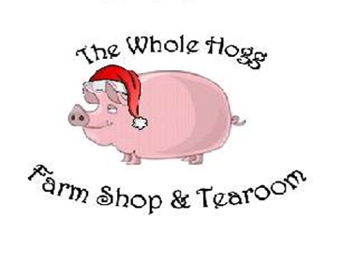

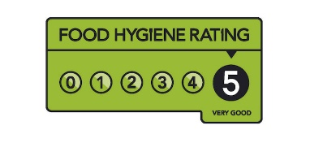
 Nah’ then, appy’ Christmas
Tis the season of Christmas
Get ya self all wrapped up wi’ Christmas
Name
Telephone
Date Required | 22nd 23rd 24th
Deposit Paid: DATE | Final Payment: DATE

Reindeer - Classic Christmas Dinner £85
2kg+ Easy Carve Boneless turkey, garnished with streaky bacon (Serves 5-6), 12 pigs in blankets, 1.5kg English Gammon joint, 1Lb Traditional sausage meat. Luxury festive Stuffing in an oven ready tray

Elves - Classic Christmas Selection £130
3kg+ Easy Carve Boneless turkey, garnished with streaky bacon (serves 8-10), 18 pigs in blankets, Approx 1.5kg Pork roasting joint, Approx 1.5kg Ryedale dry aged beef roasting joint, 1.5kg English gammon joint, 1LB Traditional sausage meat, Luxury Festive stuffing in an oven ready tray.

Father Christmas - Classic Collection of Christmas Meats £180
5kg Boneless turkey, garnished with streaky bacon (serves 15-18), 24 pigs in blankets, 2kg Pork Loin roasting joint, 2kg Ryedale dry aged beef roasting joint, 1.5kg English gammon joint, 2Lb Traditional sausage meat, Luxury Festive Stuffing in an oven ready tray.
Please circle the pack you wish to purchase below
Reindeer | Elves | Father Christmas

Poultry- Meat - Game | Size | Quantity required
Free range Turkey £17.95 kilo | 3-6 people (Small) 3kg
“British Bronze Free Range Turkey” | 6-9 people (Medium) 4kg
 | 9-13 people (Large) 5kg
 | 13+ people (X-Large) 6kg
Boneless Turkey Breast £18.95kg
 | 2kg+ 4-6 ppl
 | 3kg+ 8-10 ppl
 | 5kg+10+ ppl
Free Range Geese £22.00kg |  | 4kg 5kg 6kg
Chicken £9.00 (each) | Approx. 1.5kg
Free Range herb fed Chicken
£8.00 per kilo
Beef Topside | £18.50kg
Pork leg boned and rolled | £11.90kg
Loin of Pork | £12.99kg
Corner Gammon | £9.95kg
What t’ order
6 kg +15+ pp

THE DELI
Product | Size | Quantity required
Pork Pie | Small £3.00
 | 1Lb £6.00
 | 2Lb £12.00
 | 4Lb £24.00
Sausage Rolls | £1.50 each
Proper Pasties | £2.95 each
Quiche | Large £6.95
 | Small £4.95
Pies - £7.95
 | Steak
 | Steak & Ale
 | Chicken & Ham
 | Chicken & Leak

We’ve a few new bits n’all!
Vegetable boxes where we peel & prepare everything you need!
A Selection Box… no queuing at the supermarket!
Take the hassle out of Christmas dinner with our pre-prepared vegetable selection box, packed with essentials to create a perfect Christmas dinner….
2-4 ppl £21
4 – 8 ppl £42

650g Roasting potatoes
750g Mashing potatoes
500g Brussel Sprouts
500g carrot batons 500g parsnip batons
500g Cauliflower Florets
400g Broccoli Florets
500g Diced swede
2 English onions sliced
4 Leeks sliced

325g Roasting potatoes 650g Roasting potatoes
375g Mashing potatoes 750g Mashing potatoes
250g Brussel sprouts 500g Brussel Sprouts
250g Carrot Batons 500g carrot batons
250g parsnips batons 500g parsnip batons
250g Cauliflower Florets 500g Cauliflower Florets
200g Broccoli Florets
200g Diced Swede
1 English Onion Sliced
2 Leek Sliced

SIDES
Red Cabbage | 3.95
Yorkshire pudding x4 | 3.95
Gravy - £4.50 | Turkey
 | Beef
Cranberry Sauce | 3.49
Apple Sauce | 3.49
Duck fat | 5.50
Goose Fat | 6.75
Traditional Homemade Stuffing | 5.95
Sausage Meat | 5.95
Pigs in Blankets | Pack of 6 £3.60
Gluten Free Pigs in Blankets | Pack of 6 £3.90

Yorkshire Cheese Selection £29.95
(Ideal for Christmas day, Boxing Day or gifting)
- Wensleydale Truckle
- Fountains Gold Truckle
- Harrogate Blue
- Yorkshire Brie
- Wensleydale & Cranberry Truckle
Deli Banquet Box 2-4ppl (£28.50) or 6-8ppl (£57.00)
(Ideal for Christmas Day or Boxing Day tea)
- Slices of dry cured Ham
- Slices of succulent cooked Roast Beef
- Festive Quiche Lorraine
- Farmhouse Sausage rolls
- Traditional Pork pies
- Homemade Potato Salad
- Homemade Coleslaw
- Whole Hogg Chutney
- Crackers for Cheese
- Wensleydale Truckle
- White crusty cob

